Government Gazette Staatskoerant
REPUBLIC OF SOUTH AFRICA
REPUBLIEK VAN SUID AFRIK A

Vol. 638 28 August Augustus
2018 No. 41866

ISSN 1682-5843
N.B. The Government Printing Works will not be held responsible for the quality of
“Hard Copies” or “Electronic Files” submitted for publication purposes

41866

Regulation Gazette No. 10177 Regulasiekoerant

9 771682 584003

AIDS HELPLINE: 0800-0123-22 Prevention is the cure

The GovernmenT
ThaT miGhT occur
no fuTure
IMPORTANT NOTICE:
PrinTinG Works Will noT be held resPonsible for any errors
due To The submission of incomPleTe /
incorrecT /
illeGible coPy.
queries Will be handled in connecTion WiTh The above.
Contents

No.

General notices • alGemene KennisGewinGs
Gazette No.
Page No.

Trade and Industry, Department of/ Handel en Nywerheid, Departement van
502 Broad-Based Black Economic Empowerment Amendment Act (53/2003): Codes of Good Practice on Broad Based
Black Economic Empowerment ............................................................................................................................... 41866 4

General notices • alGemene KennisGewinGs
DEPARTMENT OF TRADE AND INDUSTRY NOTICE 502 OF 2018
CODES OF GOOD PRACTICE ON BROAD BASED BLACK ECONOMIC EMPOWERMENT

I, Dr Rob Davies, Minister of Trade and Industry hereby gazette the Youth Employment Service Initiative within Code Series 000, Statement 000 of the Amended Codes of Good Practice in terms of Section 9 (1) of the Broad- Based Black Economic Empowerment Amendment Act 2003, (Act No. 53 of 2003) as amended by the B-BBEE Act 46 of 2013 for implementation with immediate effect.

______________
DR ROB DAVIES, MP
MINISTER OF TRADE AND INDUSTRY

_____/_____/2018

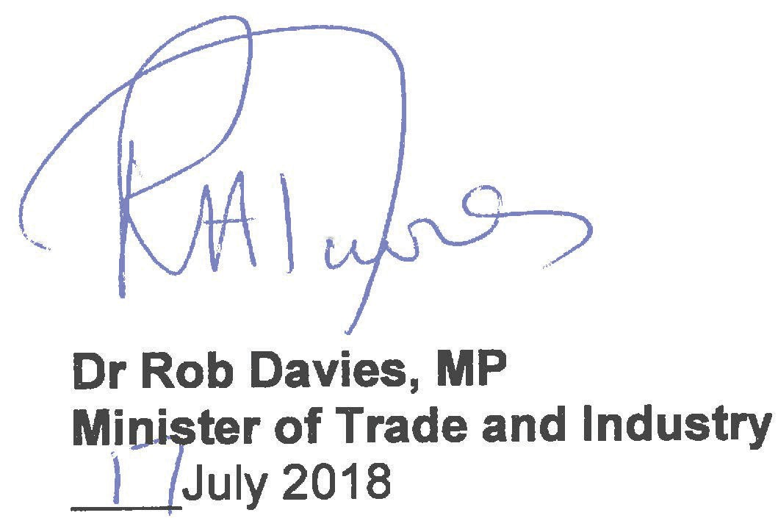

Page 1 of 9

AMENDED CODE SERIES 000: FRAMEWORK FOR MEASURING BROAD- BASED BLACK ECONOMIC EMPOWERMENT

STATEMENT 000: YOUTH EMPLOYMENT SERVICE

Issued under section 9 of the Broad-Based Black Economic Empowerment Act of 2003, as amended

Arrangement of this statement:

Para Subject
Page

Youth Employment Service Overview…………………………………….3
- Qualification for Registration for the Y.E.S Initiative…………………….3 3 The Y.E.S Targets…………………………………………………………..4 4 Eligible Employees………………………………………………………….5 5 B-BBEE Recognition………………………………………………………..5 6 Employment Conditions…………………………………………………….6
7 Informal Skills Development Expenditure for the Y.E.S Initiative………6 Annexure A…………………………………………………………………..7 Annexure B…………………………………………………………………..8

Page 2 of 9

1. YOUTH EMPLOYMENT SERVICE OVERVIEW

1.1 The Youth Employment Service (Y.E.S) Initiative is to provide for, and institute, Broad-Based Black Economic Empowerment (B-BBEE) Recognition for Y.E.S Measured Entities and qualification criteria applicable to, the B-BBEE Recognition for Job Creation.

QUALIFICATION FOR REGISTRATION FOR THE Y.E.S INITIATIVE

  - Generic entities with Total Revenue above R50 Million per annum must achieve at least the 40% sub-minimum as per paragraph 3.3 under Amended Code Series 000, Statement 000 of the Amended Codes of Good Practice under each of the priority elements of the generic B-BBEE scorecard. Alternatively, Generic entities must achieve an average of 50% across the three priority elements utilising principles under paragraph 3.3 of Amended Code Series 000, Statement 000 of the Amended Codes of Good Practice;

  - QSEs with an annual Total Revenue between R10 Million and R50 Million, must achieve at least 40% in two of the three priority elements, with Ownership being one of the two elements utilising principles under paragraph 3.3 of Amended Code Series 000, Statement 000 of the Amended Codes of Good Practice. Alternatively, QSEs must achieve an average score of 40% across two priority elements utilising principles under paragraph 3.3 of Amended Code Series 000, Statement 000 of the Amended Codes of Good Practice with Ownership being one of the two elements;

  - EMEs with an annual Total Revenue below R10 Million per annum, have no sub-minimum eligibility requirements; and

  - Y.ES Measured Entities must ensure that they maintain or improve the B- BBEE Status Level and performance against the Targets under the overall

Page 3 of 9

Scorecard obtained in the prior year before participating in the Y.E.S initiative.

THE Y.E.S TARGETS

  - Generic Entities:

    - Targets for Generic Entities will be the Higher between (i), (ii) and (iii) below:
      - 1.5% of the Y.E.S Measured Entity’s headcount in the preceding year; OR
      - 1.5% of the Y.E.S Measured Entity’s average Net Profit After Tax (NPAT) from South African operations in the immediately preceding three years, converted to a headcount number by dividing that NPAT number by R55,000; OR
      - a target as determined in Table 1 - Annexure A.

Calculation of NPAT example: For example, if Company A has an average NPAT of R500m over the past three financial years, their
Y.E.S target will be set by converting R7.5m (1.5% of a R500m NPAT) to a headcount number of 137 employees (R7 500 000 / R55 000).

Headcount vs NPAT example: For example, if Company B employs 10 000 employees and has an average NPAT of R100 Million, the target calculation would be as follows:

Target based on NPAT: (1.5% of R100 000 000) / R55 000 = 28 employees:

Target based on headcount: 1.5% of 10 000 = 150 employees

Page 4 of 9

In this case Company B’s new position target would be 1.5% of headcount – or 150 employees - as their NPAT target equates to less than 1.5% of their headcount.

  - QSEs AND EMEs

    - These entities target per annum are based on headcount numbers as determined in Table 2 - Annexure B.

ELIGIBLE EMPLOYEES

  - Only individuals who meet the below criteria are eligible for participation under the Y.E.S Initiative:

    - are between the ages of 18 and 35; and
    - meet the definition of “Black People” as defined in the Broad-Based Black Economic Empowerment Act 53 of 2003 as amended by Act 46 of 2013

B-BBEE RECOGNITION

  - The table below outlines the numerous levels of B-BBEE Recognition achievable through the Y.E.S initiative, provided the preconditions are met.

B-BBEE RECOGNITION
Achieve Y.E.S Target and 2.5 % Absorption | Move 1 B-BBEE Recognition Level up on the Scorecard
Achieve 1.5 x Y.E.S Target and 5% Absorption | Move 1 B-BBEE Recognition Level up on the Scorecard + 3 Bonus Points to the overall Scorecard
Double Y.E.S Target and 5 % Absorption | Move 2 B-BBEE Recognition Levels up on the Scorecard

Page 5 of 9

EMPLOYMENT CONDITIONS

Y.E.S Measured Entities engaging eligible employees in new positions are subject to South African legislation governing basic conditions of employment and working conditions;
  - Y.E.S Measured Entities are required to sign fixed term or temporary employment contracts with all eligible employees filling new positions within their Entity. These new positions must have a 12-month fulltime work experience paid for by the Entity;
  - Y.ES Measured Entities must commit to ensuring a quality work experience is provided to the eligible employee insofar as the entity is able to provide it;
  - Clear communication must be provided to the employee should the contract not be renewed or extended into permanent placement;
  - The new jobs must be created in addition to existing headcount. Y.E.S Measured Entities may not replace existing positions with new positions; and
  - Where Y.E.S Measured Entities are unable to create a sufficient number of new jobs within the entity to meet their targets, they may sponsor new jobs to be placed in EMEs or QSEs. The sponsored positions will contribute to meeting the Y.E.S Measured Entity’s target.

- INFORMAL SKILLS DEVELOPMENT SPEND FOR THE Y.E.S INITIATIVE

  - Informal Skills Development expenditure for Y.E.S employees will be recognised during the Verification Process of the Skills Development element under Amended Code Series 300, Statement 300. Y.E.S Measured Entities will be able to claim up to 50% of their Skills Development Spend as Informal Training (Category F and G of the Skills Development Matrix) against the Skills Development Scorecard.

Page 6 of 9

TABLE 1 - ANNEXURE A: GENERIC ENTITY TARGETS

TOTAL REVENUE BAND (RM) | MINIMUM BLACK YOUTH JOBS
50 – 75 | 6
75 – 99 | 7
100 – 149 | 8
150 – 199 | 9
200 – 249 | 10
250 – 299 | 11
300 – 349 | 12
350 – 399 | 13
400 – 449 | 14
450 – 500+ | 15

Page 7 of 9

TABLE 2 - ANNEXURE B: EME / QSE HEADCOUNT TARGETS

EME / QSE HEADCOUNT | Y.E.S YOUTH TARGET
1 – 19 | 1
20 – 39 | 2
40 – 59 | 3
60 – 79 | 4
80 – 99 | 5
100 – 119 | 6
120 – 139 | 7
140 – 159 | 8
160 – 179 | 9
180 – 199 | 10
200 – 219 | 11
220 – 239 | 12
240 – 259 | 13
260 – 279 | 14
280 – 299 | 15
300 – 319 | 16
320 – 339 | 17

EME / QSE HEADCOUNT | Y.E.S YOUTH TARGET
400 – 419 | 21
420 – 439 | 22
440 – 459 | 23
460 – 479 | 24
480 – 499 | 25
500 – 519 | 26
520 – 539 | 27
540 – 559 | 28
560 – 579 | 29
580 – 599 | 30
600 – 619 | 31
620 – 639 | 32
640 – 659 | 33
660 – 679 | 34
680 – 699 | 35
700 – 719 | 36
720 – 739 | 37

Page 8 of 9

340 – 359 | 18
360 – 379 | 19
380 – 399 | 20

740 – 759 | 38
760 – 779 | 39
780 – 799 | 40

Page 9 of 9

Warning!!!
To all suppliers and potential suppliers of goods to the Government Printing Works

The Government Printing Works would like to warn members of the public against an organised syndicate(s) scamming unsuspecting members of the public and claiming to act on behalf of the Government Printing Works.

One of the ways in which the syndicate operates is by requesting quotations for various goods and services on a quotation form with the logo of the Government Printing Works. Once the official order is placed the syndicate requesting upfront payment before delivery will take place. Once the upfront payment is done the syndicate do not deliver the goods and service provider then expect payment from Government Printing Works.

Government Printing Works condemns such illegal activities and encourages service providers to confirm the legitimacy of purchase orders with GPW SCM, prior to processing and delivery of goods.

To confirm the legitimacy of purchase orders, please contact: Renny Chetty (012) 748-6375 (Renny.Chetty@gpw.gov.za),
Anna-Marie du Toit (012) 748-6292 (Anna-Marie.DuToit@gpw.gov.za) and Siraj Rizvi (012) 748-6380 (Siraj.Rizvi@gpw.gov.za)

Printed by and obtainable from the Government Printer, Bosman Street, Private Bag X85, Pretoria, 0001 Contact Centre Tel: 012-748 6200. eMail: info.egazette@gpw.gov.za
Publications: Tel: (012) 748 6053, 748 6061, 748 6065

